SWEDA logo usage, brand colours & FONTS

Correct use of the logo

We have three logos, one just a circle with SWEDA in the centre as below:

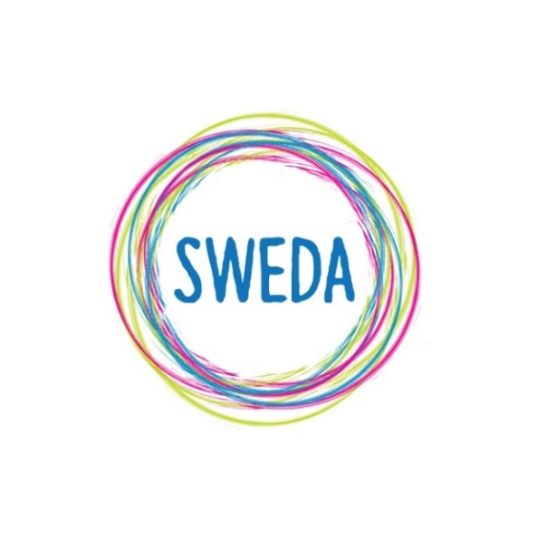
And one with our full name on:

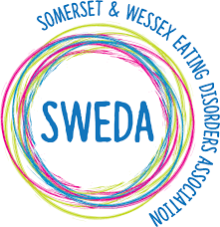

And one that can be used as a page header:

Do’s and Don’t’s

We request that if you are using our logo, you DO NOT alter it in terms of proportion by either x or y alone and should be scaled by both x and y at the same time.

Please DO NOT alter the log in any way by adding any other graphic elements such as a shadow/different colours etc.

This has been scaled correctly (both x and y)

This one hasn’t it has been scaled from left to right (x)

This one hasn’t either, it has been scaled top to bottom (y)

The logo should not be used with a shadow as below:

If you would like a black and white version of our logo or any other variations, please get in touch online.
Brand Colours

Our corporate colours breakdowns are shown below:

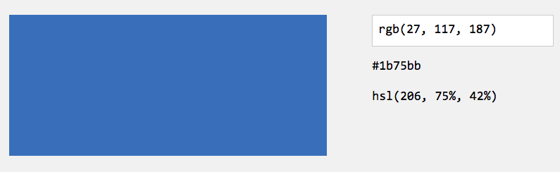

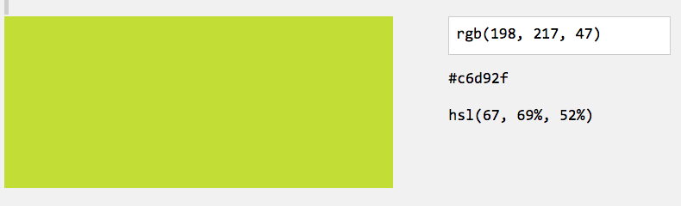

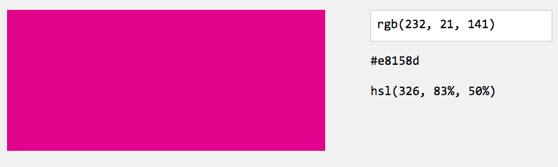

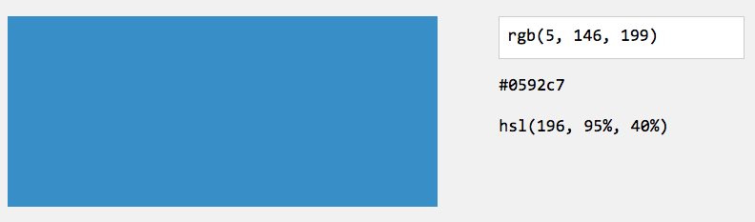

Brand FONTS

Our corporate fonts are as follows:

Headliners (including titles, emphases (not bold)) - ‘Lazing on a sunny afternoon’

Body Copy – ‘Dosis’ regular

Font Sizing Ratio

Headliners: +4pt as an example 16pt Lazing - 12pt Dosis

Body copy where you want emphasis: +2pt (eg 14pt Dosis, 16pt Lazing on a Sunny Afternoon)

